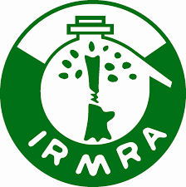 | Indian Rubber Manufacturers Research Association  (Affiliated to Ministry of Commerce and Industry, Govt. of India) | Doc. No: IRMRA/NABET/NF  Rev. No.: 00  Date: 18/09/2017
NOMINATION/REGISTRATION FORM
IRMRA/ LMTC/07/19-23
On
“Quality Assurance through Inspection and Testing of Automotive Rubber Products”

Venue | : IRMRA, Thane, Maharashtra
Duration: | : 02 Days: 18th to 19th May 2023; Time: 10.00 am to 05.00 pm
Name of the Participant | :
Designation | :
Qualification | :
Company Name | :
Company Address | :
Tel.No/Mob. No | :
Email Id | :
Fax No. | :
Stay During Course | : Residential /Non Residential
Signature | Seal & Signature of Sponsoring Authority
For payment: Bank details are attached herewith all details / please ask on following address
Please send your nomination(s) form dully filled in soft copy to the following address:

Course Coordinator: - Dr. Rupesh Rohan, Assistant Director
Indian Rubber Manufacturers Research Association
(Affiliated to Ministry of Commerce & Industry, Govt. of India)
Plot No. 254/1B, Road N0.16V. Wagle Industrial Estate, Thane (West) PIN - 400604. Maharashtra, India
Tel. No. : (+91)-22-67873200(19-lines).Tele Fax: (+91)-22-25823910
Mobile: 7275247393, 8291404906 9987300581 Mr.Amol Tadke 9987300581,Ms. Shalini Singh 7900079149

Email: rr@irmra.org / infotrg@irmra.org / trg@irmra.org Website: www.irmra.org

